Bài thực hành chương 6
KIỂM THỬ HỘP TRẮNG (tt)

I. Kỹ thuật kiểm thử dùng bảng quyết định
Attending Stateless University is an expensive proposition. After all, they receive no state funding. Like many other students, those planning on attending apply for student aid using FAFSA, the Free Application for Federal Student Aid. The following instructions were taken from that form. Examine them and create a decision table that represents the FAFSA rules.
Step Four: Who is considered a parent in this step?
Read these notes to determine who is considered a parent for purposes of this form. Answer all questions in Step Four about them, even if you do not live with them.
Are you an orphan, or are you or were you (until age 18) a ward/dependent of the court? If Yes, skip Step Four. If your parents are both living and married to each other, answer the questions about them. If your parent is widowed or single, answer the questions about that parent. If your widowed parent is remarried as of today, answer the questions about that parent and the person whom your parent married (your stepparent). If your parents are divorced or separated, answer the questions about the parent you lived with more during the past 12 months. (If you did not live with one parent more than the other, give answers about the parent who provided more financial support during the last 12 months, or during the most recent year that you actually received support from a parent.) If this parent is remarried as of today, answer the questions on the rest of this form about that parent and the person whom your parent married (your stepparent).
II. Kỹ thuật kiểm thử dùng bảng chuyển trạng thái
Below is a state-transition diagram for the "enroll in a course" and "drop a course" process. Determine a set of test cases that you feel adequately cover the enroll and drop process.
The following terms are used in the diagram:
Events
- create - Create a new course.
- enroll - Add a student to the course.
- drop - Drop a student from the course.
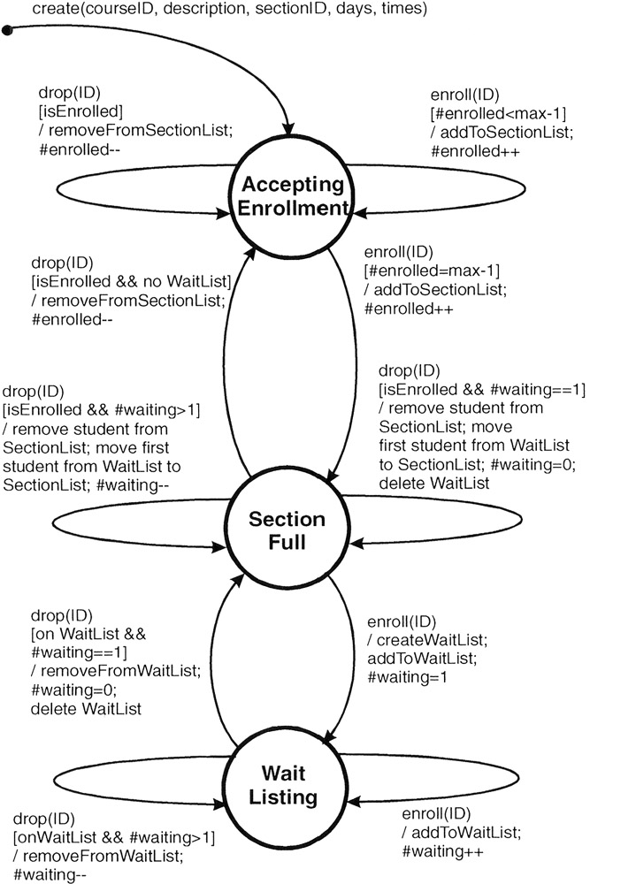Attributes
- ID - The student identification number.
- max - The maximum number of students a course can hold.
- #enrolled - The number of students currently enrolled in the course.
- #waiting - The number of students currently on the Wait List for this course.
Tests
- isEnrolled - Answers "is the student enrolled (on the Section List)?"
- onWaitList - Answers "is the student on the WaitList?"
Lists
- SectionList - A list of students enrolled in the class.
- WaitList - A list of students waiting to be enrolled in a full class.
Symbols
- ++ Increment by 1.
- Decrement by 1.
III. Kỹ thuật kiểm thử dùng use-case
Given the "Register For A Course" use case for the Stateless University Registration System described below. Create a set of test cases so that the main success scenario and each of the extensions are tested at least once. Choose "interesting" test data using the equivalence class and boundary value techniques.
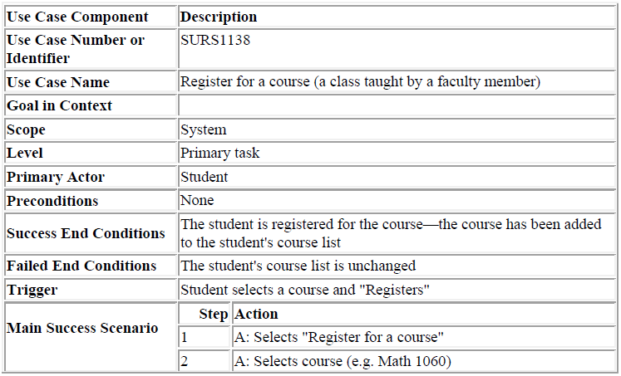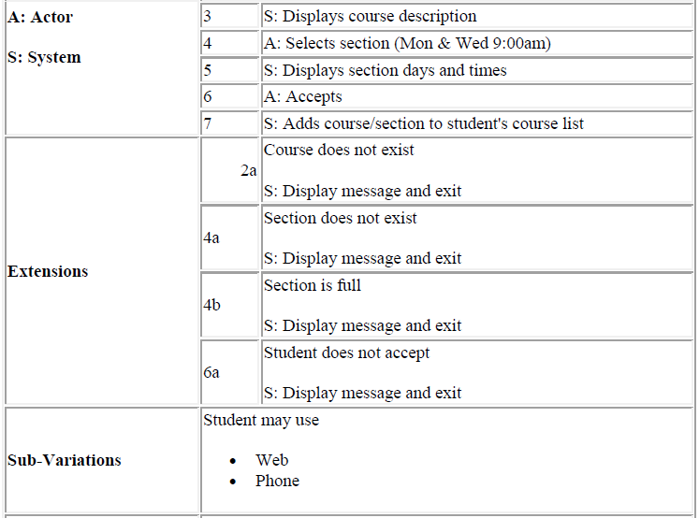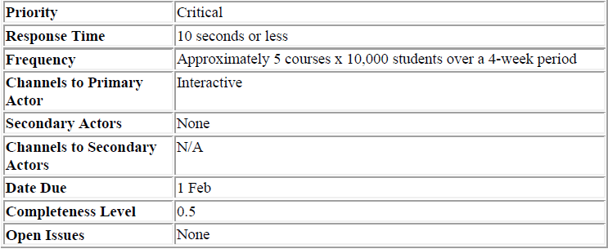
IV. Kỹ thuật kiểm thử dùng các bộ n kỳ diệu
Determine the set of pairwise test cases
A bank has created a new data processing system that is ready for testing. This bank has different kinds of customers—consumers, very important consumers, businesses, and non-profits; different kinds of accounts—checking, savings, mortgages, consumer loans, and commercial loans; they operate in different states, each with different regulations—California, Nevada, Utah, Idaho, Arizona, and New Mexico.

